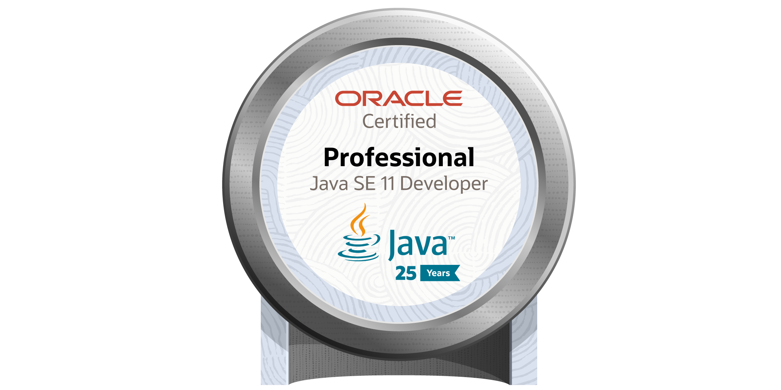
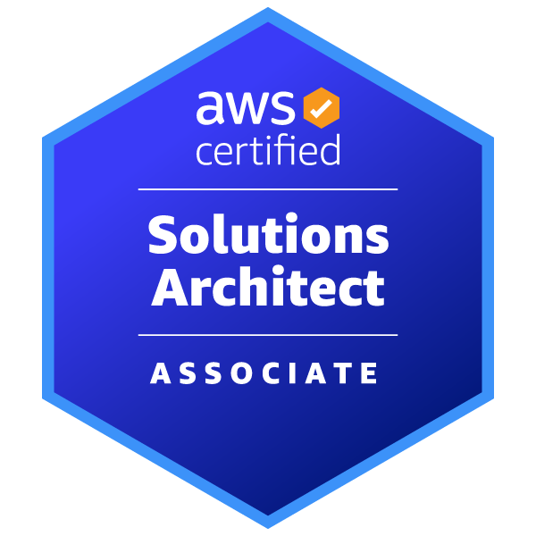

Lakshmi Priya Bonda
Email: bondalakshmipriya@gmail.com
Ph#: 469-527-5977
LinkedIn: www.linkedin.com/in/lakshmi-priya-8489b4348

Professional Summary:

- Over 10+ Years of experience as a Java Developer/J2EE Web Developer with diversified exposure in analysis, design, development, and implementation of web-based applications.
- Experience in all phases of Software Development Life Cycle (SDLC), including system Analysis, Design, Implementation, Testing, and Deployment.
- Experience in designing and implementing multi-tier applications using web-based technologies like Spring MVC and Spring Boot.
- Experience in building web services using various Spring Framework features like Spring IOC, Spring MVC, Spring AOP, and Spring ORM.
- Experienced in Middleware persistence frameworks like Hibernate/JPA Entities for mapping Java classes using Hibernate Query Language (HQL), HSQL Named Queries, Criteria, and Projections.
- Experience in XML technologies such as XSL, XSLT, XML schemas, XPath, XSL-FO, and parsers like SAX.
- Experience in Core Java concepts like Collections, Multithreading, Event Handling, Exception Handling, and Generics.
- Experience with Docker containers, leveraging Linux Containers and AMIs to create Docker Images/ containers.
- Experience in message streaming using Apache Kafka.
- Experience in Amazon Web Services (AWS) environment and good knowledge of AWS services like Elastic Compute Cloud (EC2), Elastic Container Service, Elastic Load Balancing, Amazon SQS, AWS Identity and Access, Amazon RDS, Simple Storage (S3), Elastic Beanstalk, and Cloud Watch.
- Experience with application servers like WebLogic, JBOSS, Apache Tomcat, and IBM WebSphere.
- Experience on docker creation and deployment on a local machine or remote machine, cooperated with Jenkins.
- Experience in the integration of Enterprise Java Beans (EJB) with existing applications and using services provided in distributed applications through Web Services (JAX-RPC, JAX-WS, JAX-RS).
- Experience in working with Log4J for logging, debugging, and error tracing.
- Experienced in writing JUnit Test cases for Java and JEE applications.
- Experience in implementing SOA (Service Oriented Architecture) using Web Services (SOAP, WSDL, RESTful) and REST service.
- Experienced with tools like JIRA for bug tracking.
- Experience in writing SQL queries, Stored Procedures for accessing and managing databases such as Oracle, DB2, and MySQL.
- Experience in working with software development methodologies like Waterfall and Agile (Daily Scrum Calls, Sprints).
- Experienced in developing and deploying scalable Spring Boot microservices, building REST APIs, optimizing backend performance, and securing integrations using OAuth2 and JWT across AWS and Kubernetes environments.
- Exceptional ability to quickly master new concepts and a proactive team player with good analytical skills and ability to perform at a high level, meet deadlines, and adapt to ever-changing priorities.

Technical Skills:

- Languages: Java 17/11/8, PL/SQL, SQL
- Java/J2EE Technologies: Core Java, JMS, Java Beans, EJB, Tiles, Design Patterns, RabbitMQ, ActiveMQ.
- Frameworks: Spring, Hibernate, Spring Boot, Spring , Spring Security, Spring Cloud
- Web Services/Cloud: SOAP, REST, AWS
- Design & GUI Tools: Eclipse, IBM RAD
- App servers: IBM Web Sphere, Apache Tomcat, BEA Web Logic, JBoss
- Version Controls: SVN, CVS, GitHub , Git, Maven, Jenkins
- Databases/Tools: Oracle, SQL Server, My-SQL, PostgreSQL, MongoDB (NoSQL)
- Methodologies: Agile, Waterfall
- Cloud: AWS (EC2, RDS, S3, IAM, CloudWatch)
- Containerization: Docker, Kubernetes, AWS EKS
- Testing: JUnit, Mockito
- Operating Systems: Windows, Linux, UNIX

Professional Experience:

Client: Discover Financial Services, River Woods, IL. Duration: Jun 2024 – Till Date
Role: Java Developer
This project aims to enhance and maintain critical financial applications, ensuring reliable performance and compliance with relevant regulations. Contributed to the development and improvement of systems supporting credit card processing, customer account management, and transaction workflows. Worked on the full project lifecycle from requirements gathering to deployment, aligning deliverables with business goals and customer experience standards. Played a key role in implementing scalable solutions that improved operational efficiency and supported ongoing digital transformation initiatives.
Responsibilities:
- Involved in various phases of Software Development Life Cycle (SDLC), including requirement gathering, modeling, analysis, architecture design, prototyping, developing, and testing.
- Developed responsive J2EE Web Applications using Java 17 and cutting-edge technologies.
- Developed robust, high-performance Java application using Java 17 and J2EE, ensuring code quality and adherence to best practices.
- Developed the application using Spring Framework that leverages classical Model View Controller (MVC) architecture.
- Developed RESTful web services using Jersey for JAX-RS implementation using Spring Boot and microservice Architecture.
- Implemented Micro-services using Java 17 built upon Spring Boot Services.
- Involved in using Spring Data JPA (Java Persistence API) framework and JPA Specification criteria builder to work with dynamic queries in Java.
- Developed the persistence layer using the Hibernate Framework by configuring the mappings in the hibernate mapping files, and created DAO and PO.
- Worked on Eclipse as IDE tool to build up applications.
- Configured JMS Server setup and DB Connection pool setup, and deployed returned items in WebSphere Server.
- Involved in writing the parsers for parsing and building the XML documents using SAX and DOM Parsers.
- Involved in using AWS (Amazon Web Services) services like EC2, VPC, Cloud Watch, Cloud Front, Cloud Formation, IAM, S3, Amazon RDS, Elastic Cache, SNS, and SQS.
- Responsible for creating and maintaining the Docker containers, also implemented the build stage to build the microservice and push the Docker container image to the private Docker registry.
- Used Cloud Watch to create CloudWatch alarms, used the Amazon EKS (Elastic Kubernetes Service) service with Kubernetes to manage the clusters.
- Involved in designing Kafka messaging queues.
- Built and maintained RESTful APIs and microservices using Java 17 and Spring Boot for backend integrations.
- Implemented OAuth2.0 and JWT authentication for secure API access.
- Optimized performance of backend services and queries using Actuator metrics and SQL tuning.
- Deployed and managed Dockerized microservices on AWS EKS clusters with Kubernetes orchestration.
- Built CI/CD pipeline and configured all the credentials and users in Jenkins.
- Used Jasmine and Karma for unit testing the Application.
- Developed a JUnit test framework and executed unit test cases by using JUNIT for fixes.
- Set up the continuous Integration (CI) process for the application using Jenkins.
- Web Services (SOAP) were developed and published using JAX-WS and JAX-RS.
- Implemented RESTful API calls to retrieve JSON data from the database on the fly.
- Used JIRA tool for Issue/bug tracking, monitoring of work assignments in the system.
- Worked on MongoDB database concepts such as locking, transactions, indexes, Sharding, replication, schema design, etc.
- Developed and optimized complex SQL queries, stored procedures, and triggers in PostgreSQL to support business logic in Java applications.
- Used MySQL database for SQL, PL/SQL scripts, stored procedures, functions, triggers.
- Used agile software management (Scrum) that included iterative application development.

Environment: Java 17, spring, MVC, Micro Services, Spring Boot, Hibernate, RESTful, Docker, AWS, DAO, Eclipse, JMS, XML, DOM, EJB, Log4j, JUnit, Jenkins, SOAP, JSON, MongoDB, MySQL, PL/SQL, SQL, Agile and Windows.

Client: Thrivent, Minneapolis, MN. Duration: May 2023 – May 2024
Role: Java Developer
In this project focused on enhancing the company’s financial planning platform to better serve members and financial advisors. The project aimed to streamline client onboarding, improve portfolio management workflows, and integrate personalized investment recommendations. Contributed to the development of several key application features that supported user engagement, ensured regulatory compliance, and enabled smoother collaboration between advisors and clients. The enhancements led to measurable improvements in system usability, response times, and overall user satisfaction.
Responsibilities:
- Involved in SDLC requirements gathering, analysis, design, development, and testing of applications developed using agile methodology.
- Used Core Java 11 concepts like Collection Framework, Multi-threading, Concurrent Object-Oriented programming, Thread pools, and Externalization.
- Utilized Java 11's new HTTP client module to facilitate seamless communication with external APIs and services. Developed a web layer using Spring Framework to manage the project in the MVC pattern.
- Developed and implemented Web Services and used Spring Framework.
- Involved in the creation of Spring Configurations using Java 11 features, Lambda expressions, Streams, and filters.
- Utilized Spring MVC framework to implement design patterns like IOC (Dependency Injection), Spring DAO, Data Transfer objects, Business objects, and ORM Mappings.
- Developed Micro services and worked on Spring Boot, deployed applications on Pivotal Cloud Foundry (PCF).
- Built REST APIs integrating PostgreSQL and MongoDB, ensuring optimized query performance and data consistency.
- Created CI/CD pipelines using Jenkins to automate microservice builds, tests, and deployments.
- Monitored backend services and resolved production issues using CloudWatch and log aggregation tools.
- Used Spring Boot at the back-end, which helps to develop an application with ease.
- Used Hibernate framework in persistence layer for mapping an object-oriented domain model to a relational database.
- Involved in Writing JPA/Hibernate queries.
- Implemented the function to send and receive AMQP messages on RabbitMQ synchronously and asynchronously, and send JMS message to Apache Active MQ on the edge device.
- Developed XML files, Schema’s and parsed them by using both SAX and DOM parsers.
- Created Docker images using a Docker file, worked on Docker container snapshots, removing images, and managing Docker volumes.
- Scheduled, deployed, and managed container replicas onto a node cluster using Kubernetes.
- Implementation of Kafka to avoid loss of messages during handling of messages at the consumer level.
- Worked on Jenkins to monitor and provision various modules into a single platform. Troubleshoot issues along CI/CD Pipelines.
- Used EJBs in the application and developed Session beans to house business logic and integrate DAO layer.
- Worked on running integrated testing using JUNIT for building the data structures required for the Web Service.
- Jenkins is used for continuous deployment and Continuous integration process.
- Used XML web services using SOAP to transfer the remote application to different institutions.
- Worked on MongoDB database concepts such as locking, transactions, indexes, Sharding, and replication.
- Developed SQL stored procedures and prepared statements for updating and accessing data from the database.
- Designed and normalized PostgreSQL database schemas to ensure data integrity and performance.
- Implemented the project under Agile Project Management Environment and followed the SCRUM iterative incremental model & configured various sprints to execute.
- Actively participated and provided feedback constructively and insightfully during weekly Iterative review meetings to track the progress for each iterative cycle and figure out the issues.

Environment: Java 11, Spring, MVC, Spring Boot, Micro Services, Hibernate, RESTful, JMS, DOM, Docker, EJB, Log4j, JUnit, DAO, Jenkins, SOAP, XML, MongoDB, SQL, Agile, and Windows.

Client: Target Corporation, Minneapolis, MN. Duration: Mar 2022 - Apr 2023
Role: Java Developer
Worked on a retail management system aimed at enhancing the efficiency of in-store operations and improving customer shopping experience. The project involved streamlining order processing, inventory tracking, and returns management across multiple store locations. Implemented new features that aligned with business goals, supported seasonal promotions, and ensured seamless integration with existing enterprise systems. Delivered regular updates based on user feedback, resulting in improved operational workflows and increased customer satisfaction.
Responsibilities:
- Responsible for requirements analysis, technical design, implementation, testing and documentation.
- Used Java 8 fundamentals like parallel streams and filters through lambda expressions to handle searching.
- Developed modules using Java APIs, Collections, Java 1.8 (Streams), Jordan API (Dates), Multi-threading, Exception Handling, Generics, Enums, Java I/O & object-oriented design patterns.
- Developed server-side presentation layer using Spring MVC Framework.
- Used Spring Framework features like Spring IOC, Spring AOP, and Spring Batch.
- Used Microservices with Spring Boot, predicted service interacting through amalgamation of REST and MQ message broke and used Eclipse as an IDE for development.
- Developed and enhanced backend services using Java 8 and Spring Boot for real-time retail operations.
- Implemented OAuth2.0/JWT authentication and rate-limiting to secure RESTful endpoints.
- Troubleshot and optimized backend performance, reducing latency across microservice calls.
- Used microservice architecture, with Spring Boot-based services interacting through a combination of REST and Apache Kafka, Spring message broker.
- Worked with Hibernate for developing Persistence classes to interact with the database.
- Used Azure components like Service Bus to implement a communication system between mutually interacting software applications, Message Queues, and Redis Cache to support data structures such as strings, hashes, lists, sets, and sorted sets with range queries.
- Maintained existing cloud environment using Microsoft Azure
- Use Window Azure to deploy the application on cloud and manage the session
- Used Azure cloud services like worker role to perform heavy background tasks in order to make application more responsive
- Developed Message Driven Bean (MDB) for asynchronous sending of Messages using JMS.
- Designed a configuration XML Schema for the application.
- Used Spring Kafka API calls to process the messages on the Kafka Cluster setup.
- Used EJB Message-Driven Beans to initiate the daily process.
- Used Log4j to print logging, debugging, and warning information.
- Used JUnit Framework for the unit testing of all the Java classes.
- Implemented Web services components , SOAP, WSDL, and UDDI to interact with external systems.
- Created MySQL Database Objects like Schemas, Tables, Views, Stored Procedures, Indexes (cluster/Noncluster), Constraints, Triggers, Buffer Pools, User Roles, and functions.
- Participated in Agile development and worked in different sprints with daily standup meetings and progress reporting.
- Monitored team members to follow standards, guidelines and use new tools.

Environment: Java 8, spring, MVC, Spring Boot, Micro Services, Hibernate, REST, Apache Kafka, DOM, MDB, JMS, XML, EJB, Log4j, JUnit, SOAP, MySQL, Agile, and Windows.

Client: Banner Health, Phoenix, AZ. Duration: Oct 2021 – Feb 2022
Role: Java/J2EE Developer
Worked on a healthcare initiative aimed at enhancing patient care and operational efficiency across Banner Health’s digital systems. Contributed to the development and improvement of internal applications supporting patient data management, appointment scheduling, and care coordination. Ensured seamless integration with existing platforms and maintained compliance with healthcare regulations. Focused on optimizing user experience and streamlining workflows for both patients and healthcare providers.
Responsibilities:
- Participated in the discussion with the business experts to understand the Business requirements and translate them into technical requirements towards development.
- Implemented using Spring MVC components such as DispatcherServlet, ModelAndView Objects, and ViewResolver.
- Developed some standalone Micro services using Spring Boot microservice architectural patterns.
- Used Spring Boot properties like actuators and health checkers to enhance microservice implementations.
- Used Spring AOP for cross-cutting concerns and Spring IOC for loosely coupled code.
- Used Hibernate in the data access layer to access and update information in the database, and used HQL to query the database for complex data.
- Developed Message Driven Bean for asynchronous sending of Messages using JMS.
- Designed and developed XSL style sheets using XSLT to transform XML and display the information on the UI screens.
- Experience working and developing applications using Azure
- Experience working on Microsoft Azure to deploy the application on cloud and manage the session.
- Involved in planning strategies to move the existing application from on-premise to the Azure cloud platform
- Involved in developing Azure cloud services to support the cloud environment for migrated applications
- Used Log4j for logging purposes.
- Used JUnit Framework for the unit testing of all the Java classes.
- Implemented Service Oriented Architecture (SOA) and web services using SOAP with JAX-WS.
- Database development required the creation of new tables, PL/SQL stored procedures, functions, views, indexes and constraints, triggers , and required SQL tuning to reduce the response time in the application.
- Followed AGILE methodology with SCRUM meetings.
- Presented website mockups to clients to give them a better visual of the end product and to ensure that all parameters were met.

Environment: Java 8, spring, Spring Boot, MVC, Micro Services, Hibernate, Eclipse, REST, XML, JMS, EJB, Log4j, JUnit, SOAP, Pl/SQL, SQL, Agile, and Windows.

Company: 3i Infotech Ltd., India. Duration: Dec 2018 – Nov 2020
Worked on a large-scale enterprise application aimed at streamlining core business operations for a major banking client. The project involved the development and maintenance of key modules supporting customer onboarding, transaction processing, and reporting. Focused on enhancing system efficiency and reliability while ensuring compliance with industry standards and client-specific requirements. Contributed to continuous improvements throughout the software development lifecycle.
Role: Java Developer
Responsibilities:
- Involved in all phases of the project, from the analysis and requirement phase to delivering the project.
- Developed our application using Spring MVC framework, and core annotations were used to inject dependencies.
- Involved in writing the action classes and from beans for different modules using Spring MVC.
- Worked on spring modules like Dependency Injection, Aspect Oriented Programming and Spring Mail, Spring JMS, and Spring Security.
- Implemented the service layer using Spring with transaction and logging interceptors.
- Worked on Hibernate persistence tier. This involves developing mapping files and Hibernate (POJOs/ DAOs).
- Reviewed the code for ensuring adherence to Java coding standards.
- Used various Core Java concepts such as Exception Handling, Multithreading, and Collection APIs to implement various features and enhancements.
- Developed various DAOs for handling business logic and data manipulations from database.
- Build and maintain SQL scripts, indexes, and complex queries for data analysis and extraction.
- Developed the functionalities using Agile Methodology.
- Monitored team members to follow standards, guidelines, and use new tools.

Environment: Java, spring, MVC, Hibernate, XML, JMS, Core Java, DAO, SOAP, SQL, Agile and Windows.

Company: iNative Tech Solutions Pvt Ltd., India. Duration: Feb 2014 – Nov 2018
Role: Java Developer
This project involved the development of a comprehensive enterprise-level application aimed at streamlining business operations for a leading client in the logistics sector. The project focused on automating key workflows, improving data accuracy across departments, and enhancing user experience through intuitive design and responsive features. Implemented core functionalities and ensure timely delivery of project milestones. The solution contributed to a significant reduction in manual efforts and operational costs while enabling better decision-making through real-time data access and reporting.
Responsibilities:
- Involved in the analysis and design phase of the Software Development Life Cycle (SDLC).
- Developed application using Spring Framework that leverages spring MVC architecture.
- Developed some part of the application using Spring-MVC and IOC/Dependency Injection, integrating different layers of the application.
- Developed core Java programs for all business rules and workflows using Spring Framework.
- Used Spring Framework for implementing Dependency Injection, Spring ORM.
- Worked on the development of a data abstraction layer using the Hibernate ORM framework with Spring support.
- Wrote DAO classes to interface with the Database using Hibernate.
- Used Java Multi-Threading concept for downloading files from a URL.
- Developed XML applications using XSLT transformations.
- JMS was used to send/receive asynchronous data from various modules in the application.
- Used Log4J to print the logging, debugging, warning, and info on the server console.
- Developed JUnit test cases for all the developed modules.
- Used WSDL and SOAP protocol for Web Services implementation.
- Developed MySQL stored procedures and triggers using SQL in order to calculate and update the tables to implement business logic.
- Implemented agile methodology throughout the project development lifecycles.
- Participated in the status meetings and status updates to the management team.

Environment: Java, Spring, MVC, Hibernate, DAO, XML, JMS, Log4j, JUnit, SOAP, SQL, Agile, and Windows.

References: Will be provided upon request.

